**Bug 1 Log:  
  
H1** – Values are correct but are printing incorrectly

**Test** – Inspect service charge value just before print out

**Result** – Hypothesis incorrect: values are insane but are outputting correctly

CheckoutCTL – line 67: Breakpoint set   
getCharges hasn’t been called

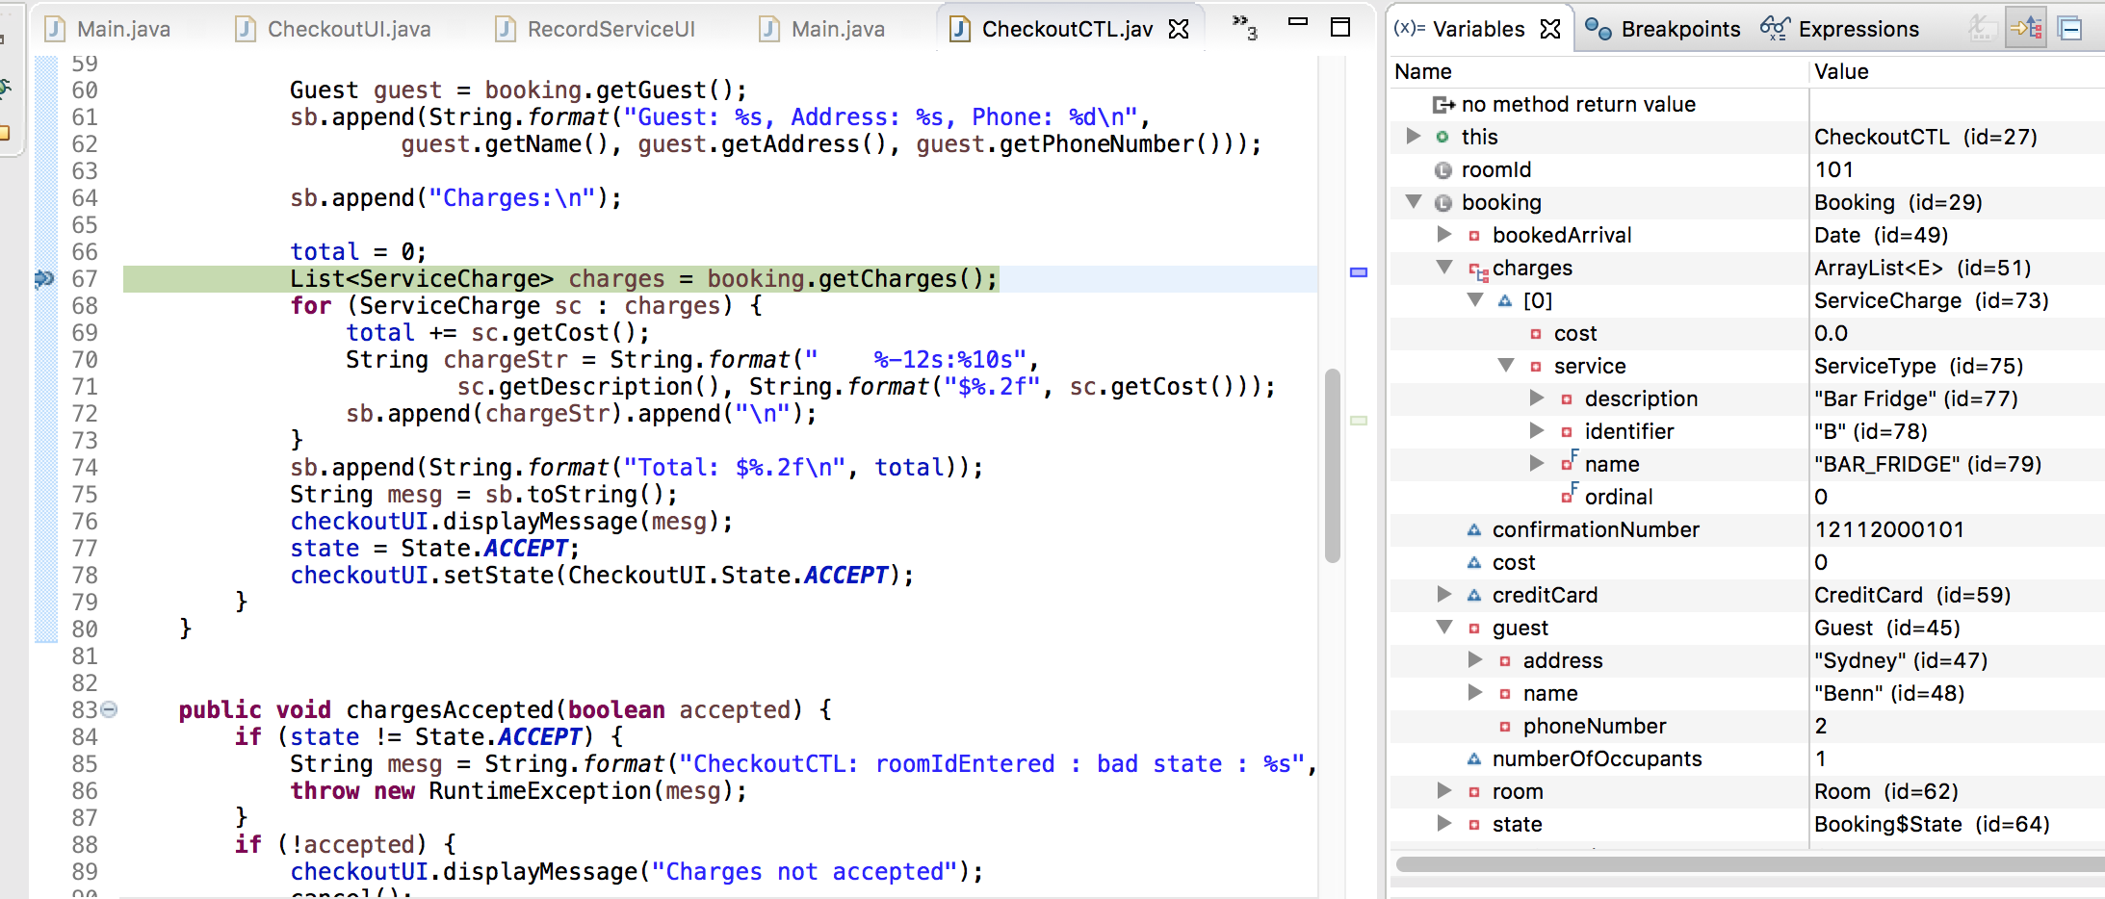

CheckoutCTL – line 68  
charges value is returned from getCharges. We can see that the service charge cost = 0.0

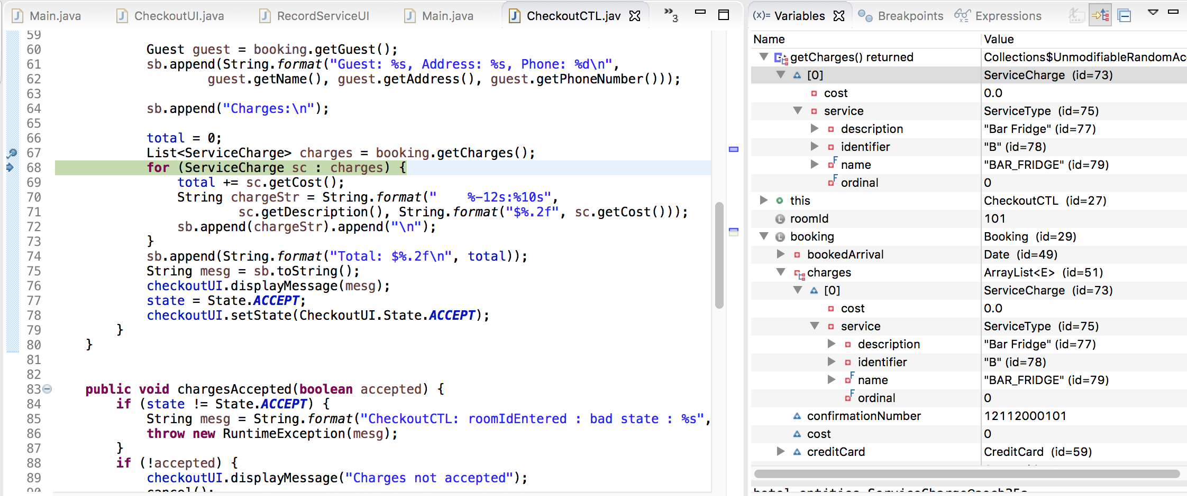

CheckoutCTL – line 69

getCost is about to be called and will assign the cost value to the total variable  
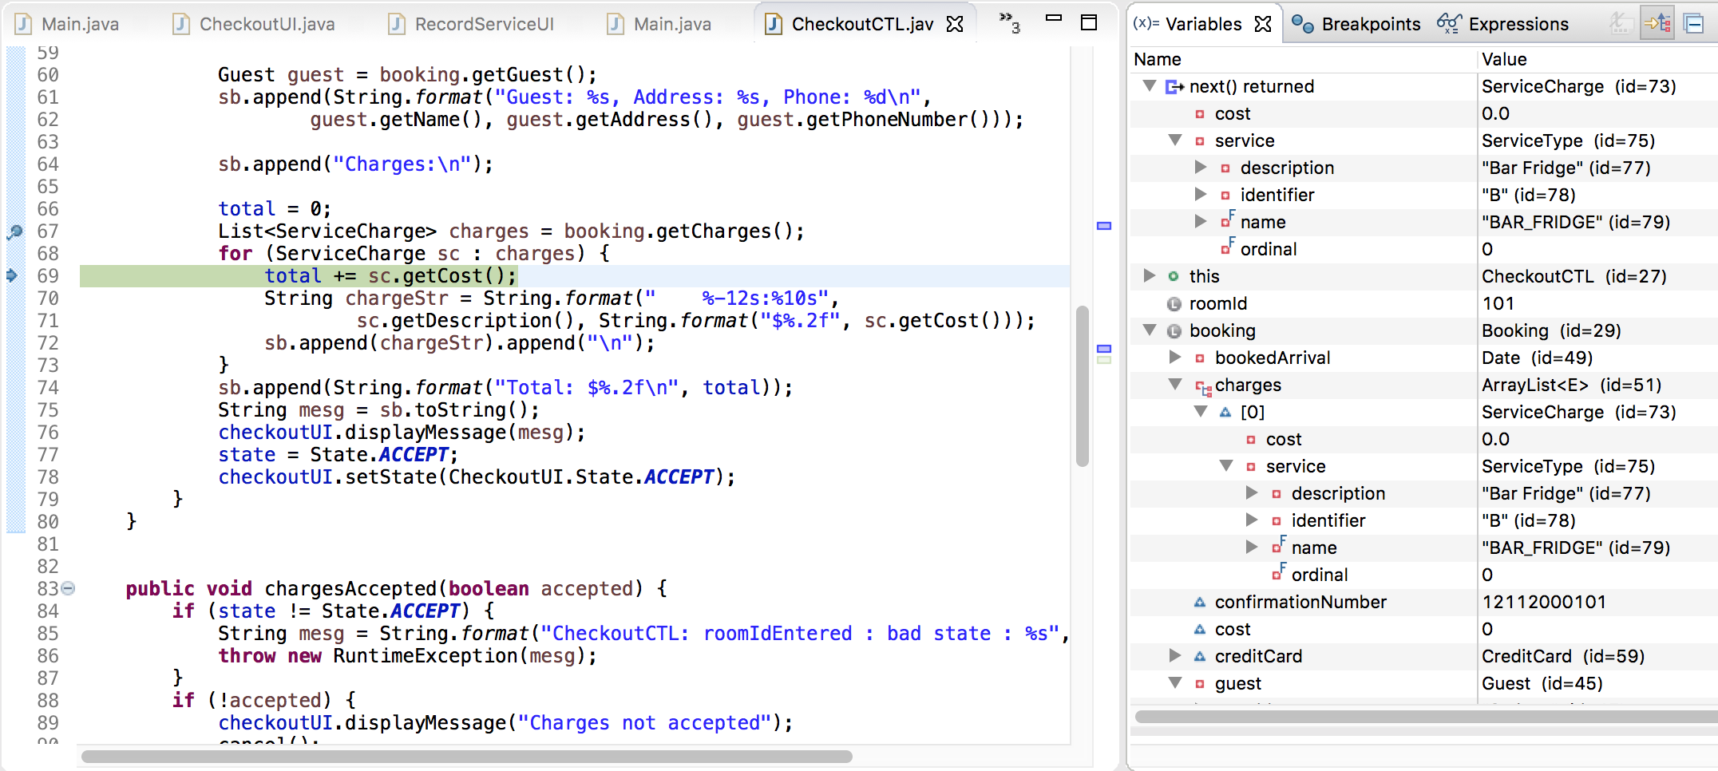

CheckoutCTL line 70  
getCost returns a value of 0.0 (insane). We can also see that the total variable is also showing 0.0

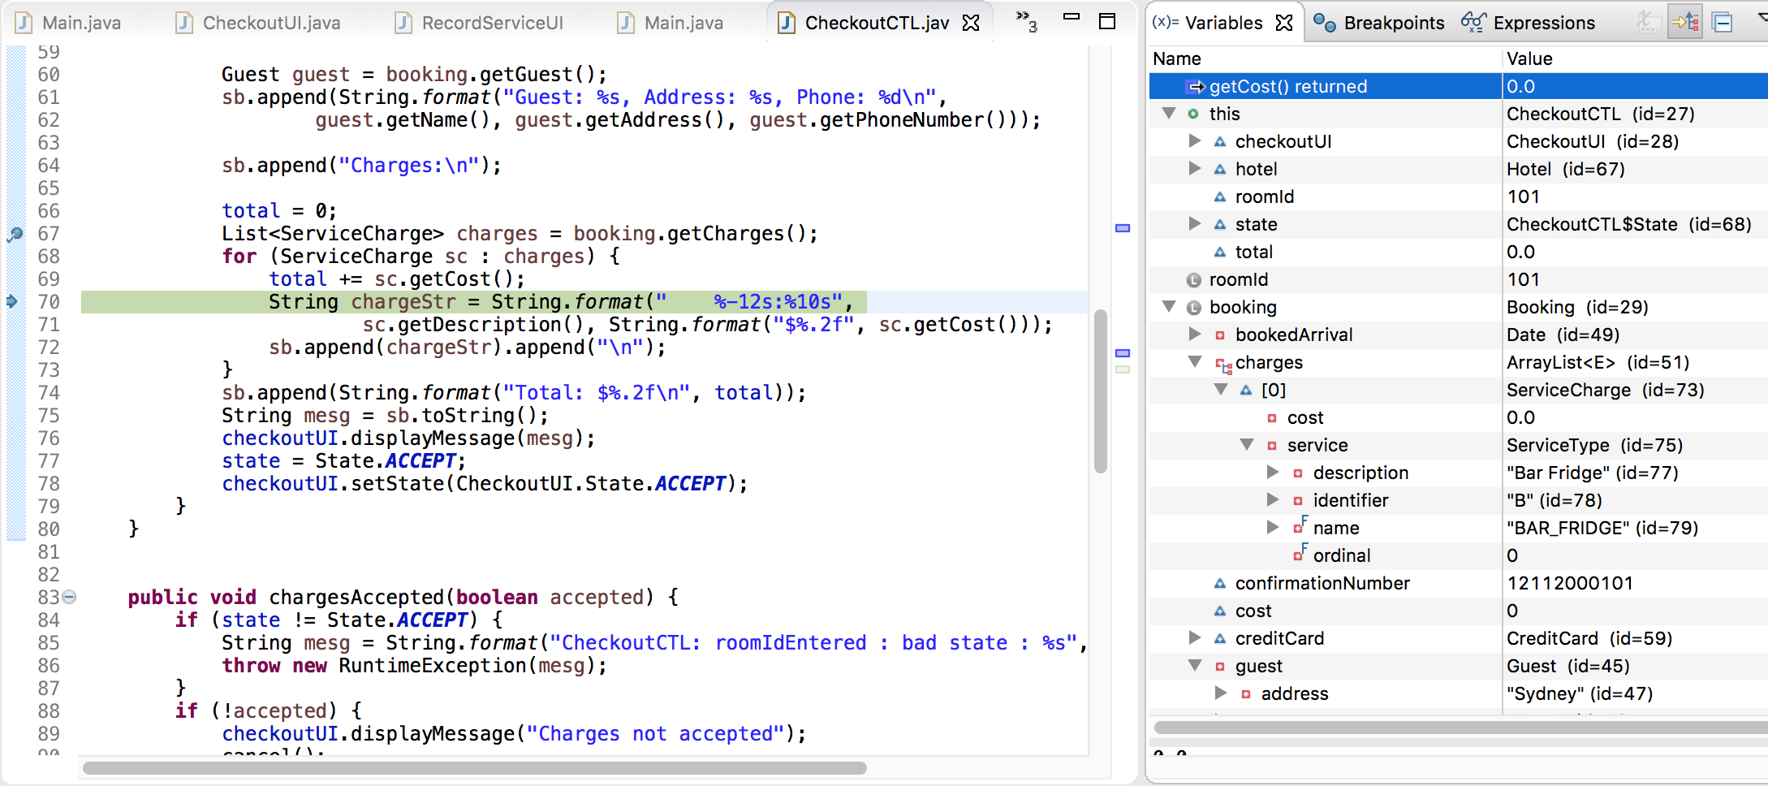

CheckoutCTL line 70 – Stepped over twice to bring up returned value for chargeStr  
We can see that the returned value for chargeStr is $0.00 (printing correctly)  
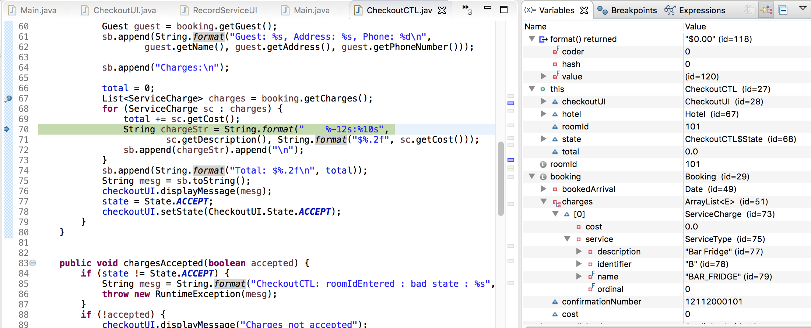

**H2** – Values aren’t coming in correctly from the UI input  
**Test** – Inspect values that are coming into RecordServiceCTL from RecordServiceUI  
**Result** – Hypothesis incorrect: values are correct before and after method call to the control class

RecordServiceUI – line 37  
We can see that there are no service details before the method call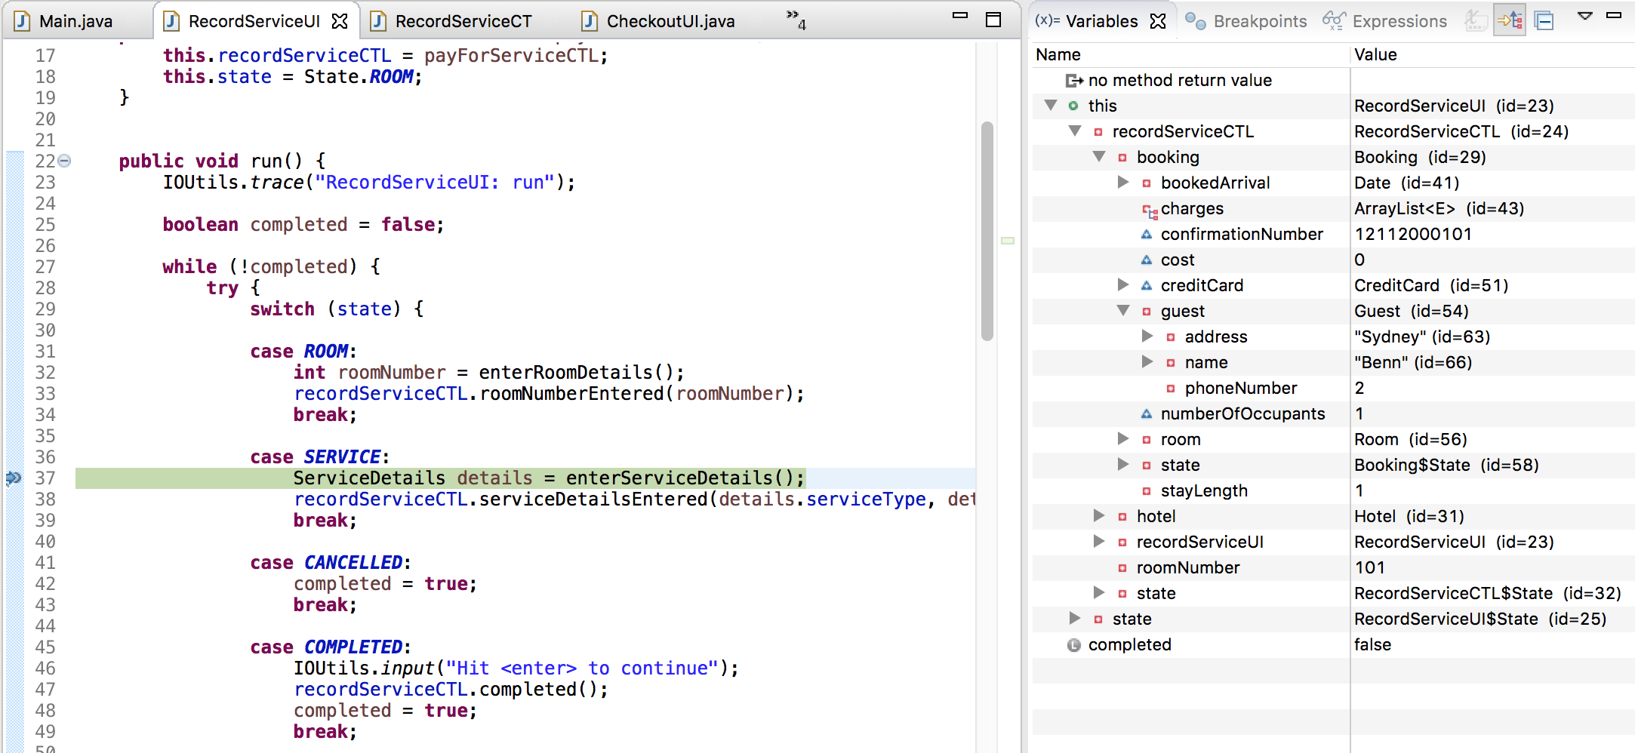

RecordServiceUI – line 38  
We can see that the variable details has been created and that its values are sane, with cost showing 5.0 after the method call where the user enters the details through the UI

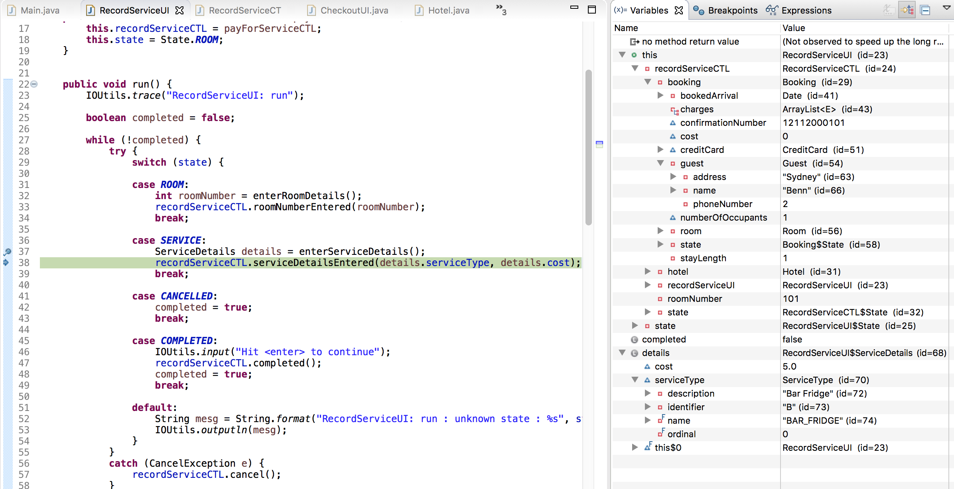

RecordServiceUI – line 39  
The details have been passed to the control class correctly and have come back sane, with cost still showing 5.0  
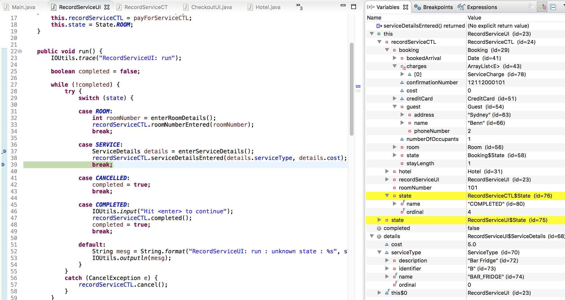

**H3** – Incorrect booking details are retrieved by the control class  
**Test** – Check what booking details come back from the roomIdEntered method  
**Result** – Hypothesis incorrect: correct booking details are coming back from findActiveBookingByRoomId when called from the roomIdEntered method

CheckoutCTL - line 44  
roomId is showing 101, which is sane

this.roomId is showing 0 as the line has not executed

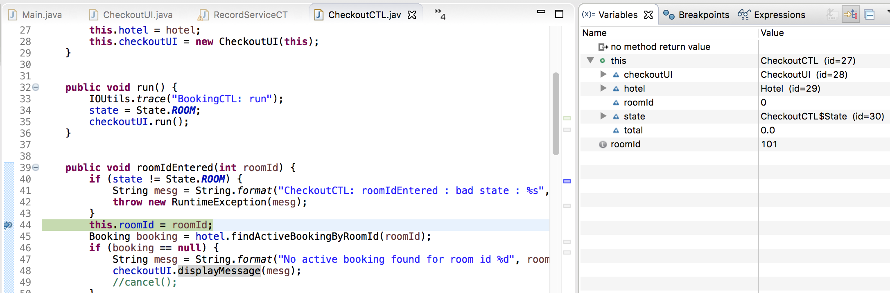

CheckoutCTL – line 45  
roomId is showing 101  
this.roomId is also now showing 101, which is sane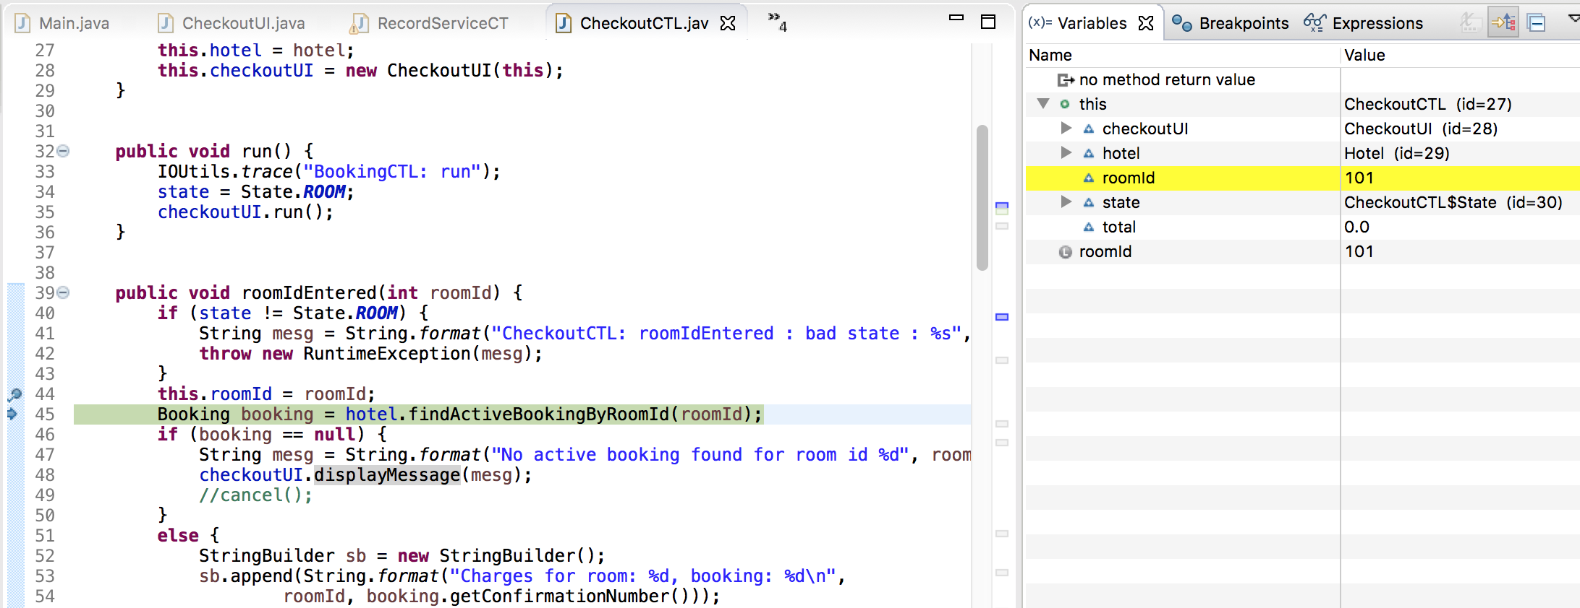

CheckoutCTL - line 46  
We can see that the booking returned from findActiveBookingByRoomId is my booking with all the correct details. It also contains the incorrect service charge with cost being 0.0  
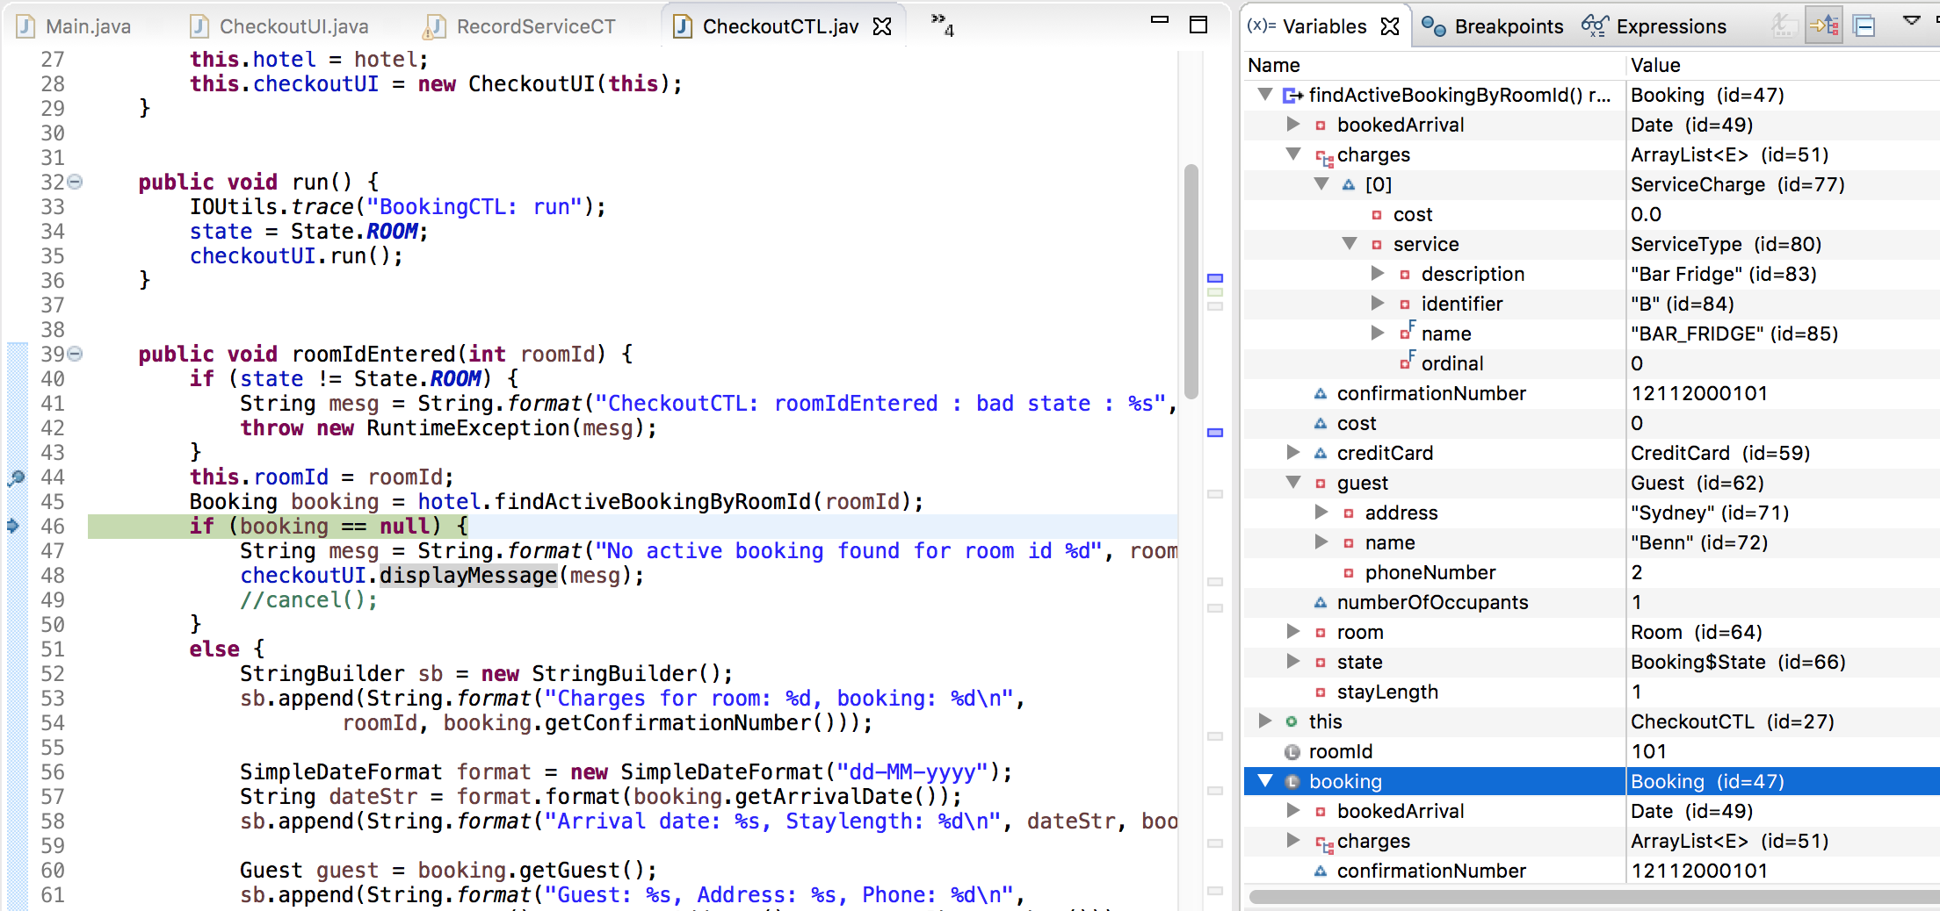

We can also see that the local variable booking has been correctly assigned all the same values  
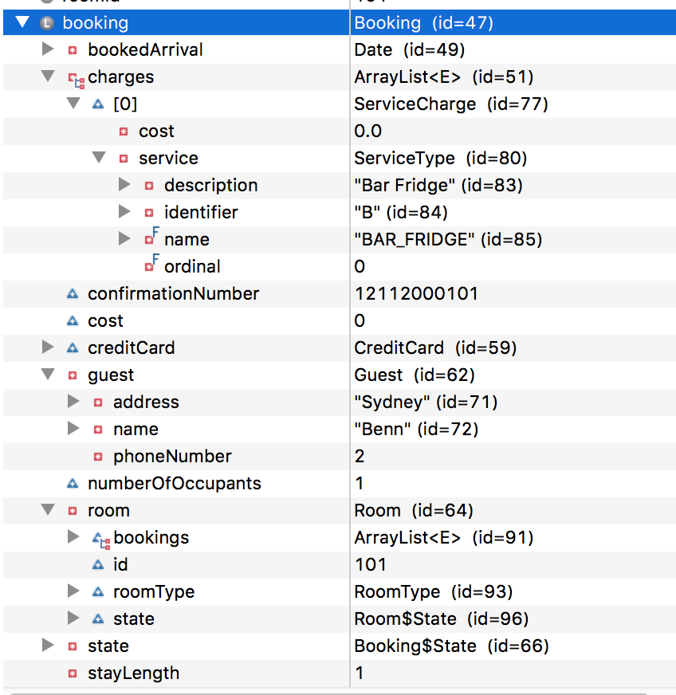  
**H4** – There is a problem assigning the cost in the Booking addServiceCharge method (working backwards through the Record Service UC)  
**Test** – Test the method call from Hotel to Booking addServiceCharge  
**Result** – Hypothesis correct: cost variable is correctly reading 5.0 before the method call, but is being assigned to a parameter called ‘cosst’ once passed to the Booking addServiceCharge method.

Hotel – line 118

We can see before the method call that all details are correct and that cost is correctly reading 5.0  
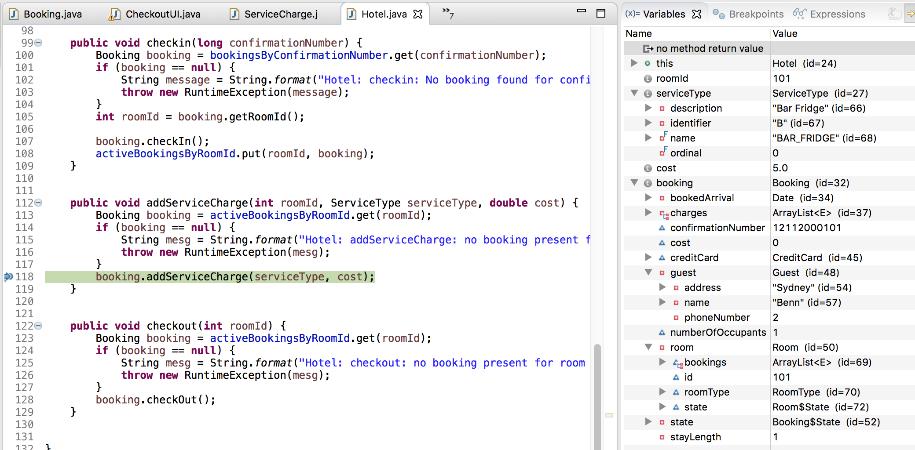

Booking – line 142  
We can see after the method call that the value for ‘cost’ has been passed to a variable called ‘cosst’. When looking at the parameters for this method we can see that there is a typo so ‘cost’ is becoming ‘cosst’.

